FOR IMMEDIATE RELEASE

January 8, 2025
Press Contact: Carl Bølling
Public Information Officer
(340)713-4268
carl.bolling@bmv.vi.gov

BMV Closure Announcement in Observance of President Carter’s Day of Mourning
[St. Croix, U.S.V.I]-Governor Albert Bryan Jr. has announced that Thursday, January 9, 2025, will be observed as a local holiday, as a result, all Bureau of Motor Vehicles (BMV) offices will be closed.
All locations will resume normal operating hours on Friday at 8:00 a.m.
We appreciate the public’s understanding as we join the nation in commemorating this solemn occasion. Please visit us online if you have any questions or concerns at: www.bmv.vi.gov
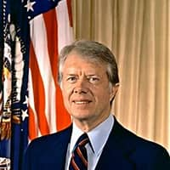
###

Carl Bølling
Public Information Officer
340)713-4268
carl.Bolling@bmv.vi.gov

