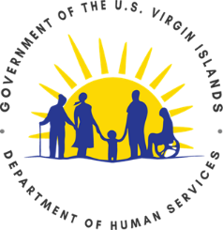

Elder, Dependent Adult, and Disabled Person
Disaster Registry

Title 34 Virgin Islands Code, chapter 16 subchapter II established the Elder, Dependent Adult, and Disabled Persons Disaster Registry. Title 34 Virgin Islands Code, chapter 16, subchapter II, section 521 states, “The Department of Human Services shall issue forms to the Bureau of Motor Vehicles and the Virgin Islands Elections System to be used to collect the information for the registry.

Last Name: First Name:

Primary Telephone: Secondary Telephone:

Physical Address:

City/Island: Zip Code:

Email Address:

Directions to the Address: (Include landmarks, color or home and all other recognizable features)

EMERGENCY CONTACT INFORMATION

Last Name: First Name:

Primary Telephone: Secondary Telephone:

Email Address:

Are you Mobile? - Yes No Are You on Medication? – Yes No Do You Live Alone? – Yes No
Signature of Registrant: __________________________________________________________________

